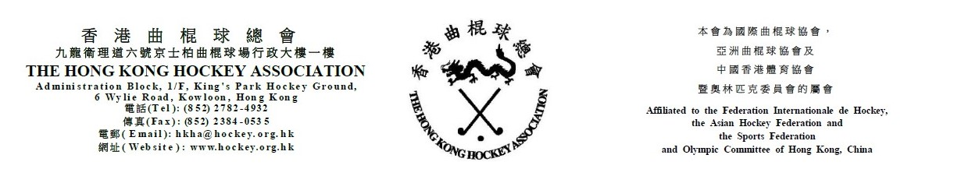

Attendance Form for
The Hong Kong Hockey Association
6th Annual General Meeting
on Wednesday, 31 July 2019
(Please see notes below before completing the form)
The following are authorized to represent __________________________________ (Member Club) at the HKHA AGM on Wednesday, 31 July 2019:-

Authorized to Vote
(tick one box only)
1. _____________________________________ ( )
(Name)
2. _____________________________________ ( )
(Name)
3. _____________________________________ ( )
(Name)

(Name of Club Official) |  | (Signature of Club Official)

(Position of Club Official) |  | (Date)

Notes: (1) Up to three persons can be authorized to attend the meeting. However, only one can be authorized to vote.
- Club officials include President, Chairman, Hon. Secretary, Convenor and Hockey Section Captain.
- This form must be received by the HKHA office no later than 5:00 pm on 24 July 2019.

